CHEMISTRY CP FINAL EXAM REVIEW Name:

- For each reaction below: identify the reaction type, predict the products and write the complete balanced reaction:
Synthesis Decomposition Single Replacement

Double Replacement Combustion

_ Decomposition __ a. iron (III) hydroxide → iron (III) oxide and water

________2Fe(OH)₃ → Fe₂O₃ + 3 H₂O ___________________________

_ Combustion______ b. ethylene (C₂H₄) burns in pure oxygen →

________ C₂H₄ + 3O₂ → 2CO₂ + 2H₂0___________________________

__ Synthesis ________ c. magnesium + nitrogen →

_________3Mg + N₂ → Mg₃N₂_________________________________

2. Complete and balance the reactions below in the space provided.

__2___KOH + _____ Pb(NO₃)₂ → _____ Pb(OH)₂ + __2___ KNO₃

_____ Cl₂ + __2___NaBr → _2_NaCl + Br₂

Chapter 12- Stoichiometry

3. Find the molar mass of dicarbon tetrachloride.

C₂Cl₄ C: 2 X 12.01 g /mol
Cl: 4 X 35.45 g/mol
165.82 g/mol

4. How many molecules are in 14.0 g of dicarbon tetrachloride.

14.0 g C₂Cl₄ x 1 mol C₂Cl₄ x 6.02 X 10²³ C₂Cl₄ = 5.08 X 10²² C₂Cl₄
165.82 g C₂Cl₄ 1 mol C₂Cl₄

5. Sodium reacts with calcium chloride to produce sodium chloride and calcium metal.
a. Balance __2__Na + ____CaCl₂ → ____Ca + __2__NaCl

b. If 43.0g of calcium chloride reacts, how many grams of sodium chloride will be produced?
(ans: 45.3g NaCl)

43 g CaCl₂ x 1 mol CaCl₂ x 2 mol NaCl x 58.5 g NaCl = 45.3 g NaCl
111.1 g CaCl₂ 1 mol CaCl₂ 1 mol NaCl

c. The reaction above is performed in lab, and 40.0g of sodium chloride are collected. Determine the percent error and the percent yield. (ans: 88.3% yield, 11.7% error)

% yield = 40g x 100 = 88.3% yield % error = 100- 88.3 = 11.7 %
45.3g

6. Sodium sulfate reacts with aluminum bromide.
a. Balance: ___3__ Na₂SO₄ + ___2_ AlBr₃ → ___6__NaBr + _____Al₂(SO₄)₃

b. Predict the mass of aluminum sulfate that will form if 25.0g of sodium sulfate react with 60.0g of
aluminum bromide. (ans: 20.1g Al₂(SO₄)₃)

25g Na₂SO₄ 1mol Na₂SO₄ 1mol Al₂(SO₄)₃ 342g = 20.1 g Al₂(SO₄)₃
142 g 3mol Na₂SO₄ 1mol Al₂(SO₄)₃

60g AlBr₃ 1mol AlBr₃ 1mol Al₂(SO₄)₃ 342g = 38.5 g Al₂(SO₄)₃
266.7 g 2mol AlBr₃ 1mol Al₂(SO₄)₃

c. The limiting reactant is: _________ Na₂SO₄_________________________.

7. Hydrogen reacts with nitrogen to produce ammonia (NH₃). If 4.4 liters of ammonia are produced at STP, how many grams of hydrogen reacted? (ans: 0.59g H₂)

N_{2(g)} + 3H₂ → 2 NH_{3(g)}

4.4 L NH₃ 1 mol NH₃ 3 mol H₂ 2g H₂ = 0.59g H₂
22.4 L NH₃ 2 mol NH₃ 1 mol H₂

8.Determine the volume of oxygen gas that required for the complete combustion of 25.0g of methane gas (CH₄) at STP

RXN: ___CH₄ + 2 O₂ → CO₂ + 2 H₂O _________________________________________________

25g CH₄ 1 mol CH₄ 2 mol O 22.4L O₂ = 69.8 mol O₂
16.05g CH₄ 1 mol CH₄ 1mol O₂

9. What volume of 2.5M hydrochloric acid is needed to react with 32.5g of aluminum?

RXN: _____6 HCl + 2 Al → 2 AlCl₃ + 3 H₂______________________________________________

32.5g Al 1 mol Al 6 mol HCl 1L HCl = 1.4L
27.0g Al 2 mol Al 2.5 mol HCl

Chapter 13- States of Matter

10. Use the phase diagram below to identify: a) the triple point b) the normal boiling point c) the state of the substance at 0.5atm and 25°C and d) the change that occurs as the substance is heated from 25°C to 100ºC at 0.5atm.
25 50 75 100
ºCelsius

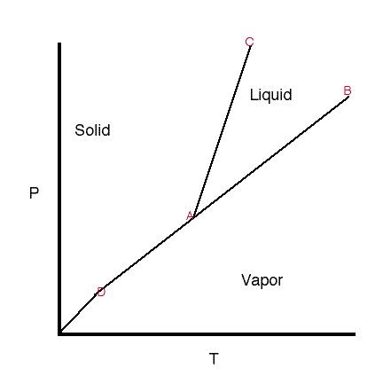
- At point A
- ~100°C
- Solid
- sublimation

1 atm

0.5atm

11. List 2 ways water could be made to boil at 105°C:

a. ____add solute particles to the water (colligavtive properties)____________________
b. ___increase atmospheric pressure____________________________________________

18. List one similarity and three differences between boiling and evaporation.

19. Define “colligative property”: Colligative properties are properties that depend only on the # of solute particles (concentration of the solute), and not the nature of the solute or solvent.

20.Describe the effect that a solute has on the boiling point, freezing point and vapor pressure of the solvent:

boiling point – is elevated, compared to pure solvent

freezing point – is lowered, compared to pure solvent

vapor pressure – lowers, compared to pure solvent

Chapter 15/16- Water and Solutions

21. Complete the table below describing the solubility of each solute.

SOLUTE | Soluble in gasoline? | Soluble in alcohol? | Soluble in water?
CBr₄ | Y | N | N
KBr | N | N | Y
CH₂O | N | Y | Y
SiO₂ | N | N | N

22. Define hydrogen bonding:
A hydrogen bond is the electromagnetic attractive interaction between polar molecules in which hydrogen is bound to a highly electronegative atom, such as nitrogen, oxygen or fluorine

23. Circle each of the molecules below that would exhibit hydrogen bonding: (Hint: you will need to draw structure)

- HF b. CH₂O c. NH₃ d. CH₄ e. H₂

24. List four properties of water that are influenced by its strong hydrogen bonds.

- high surface tension: Surface tension is a contractive tendency of the surface of a liquid that allows it to resist an external force caused by cohesion

- high specific heat capacity (absorbs a lot of heat as it warms up): amount of heat required to change the temperature of an object or body by a given amount

- cohesive forces: tendency of similar or identical particles/surfaces to cling to one another; hydrogen bonds increase cohesiveness of water

- density: solid water (ice) floats on liquid water; as water freezes, it becomes less dense

e. strong adhesive forces: water molecules have a strong attraction to other water molecules

25. Use the graph to answer the questions below:
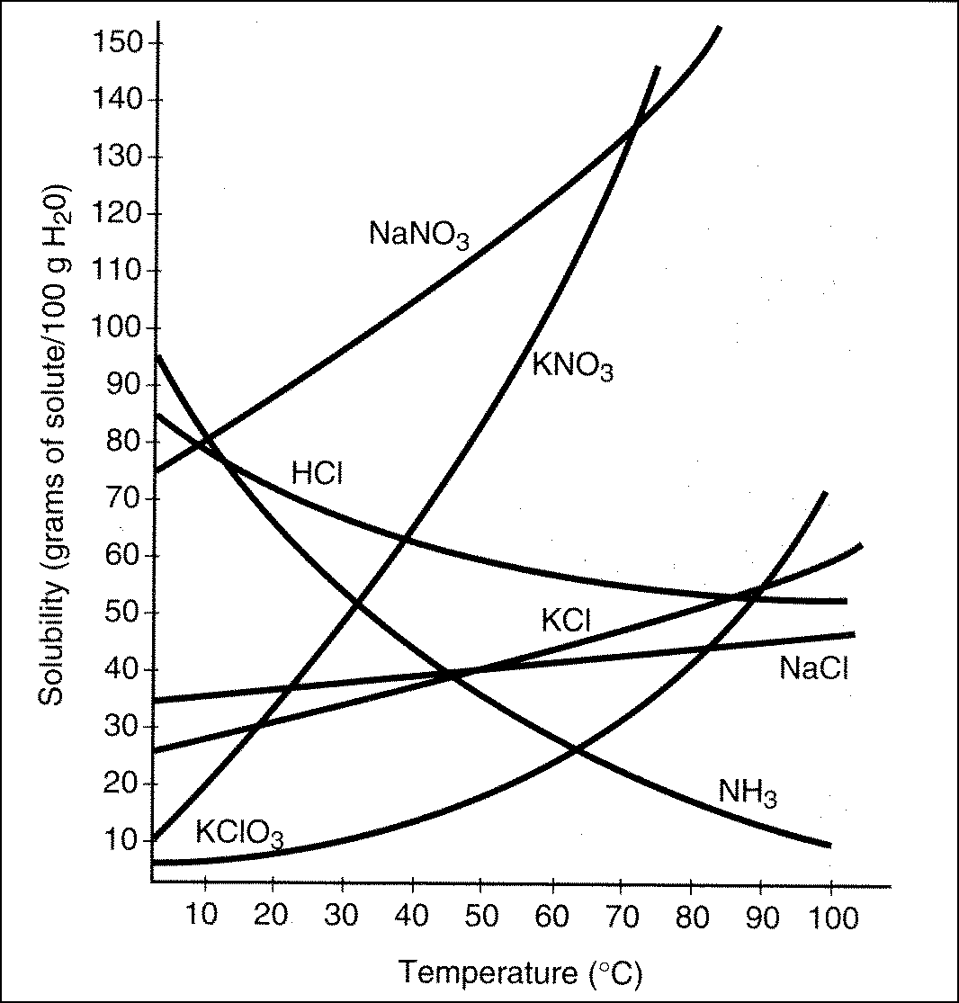

- How many grams of KClO₃ need to dissolve in 50 g of water in order to have a saturated solution at 70°C? ___15g _________
- Which substance is the most soluble in water at 0°C? ___ NH₃__________

- Which substance is least affected by temperature change? ____ NaCl _________

- Which substance is the least soluble in water at 0°C? ___ KClO₃___________

- Which substance becomes less soluble as the temperature increases? __ HCl, NH₃__________

- How would you describe the level of saturation of a solution of KNO₃ at 40°C if there are about 60g of KNO₃ in 100g of water? ___ unsaturated _________

26. Fill in the blanks of the following paragraph:

Word bank: pressure, temperature, concentration, high, low, solvent, solute

Molarity, molality, percent by mass and volume express concentration of a solution. In order to dilute a solution more of a solvent can be added. In order to make more concentrated solution more of a solute can be added.
Gases are most soluble in liquids under conditions of high pressure and low temperature.

27. Determine the molarity of a solution prepared by dissolving 15.0g of KCl in 525ml of water. (ans: 0.383M)

Hint: Formula: : M = mol solute 15 g KCl 1mol KCl = .201 mol
L solution 74.5g

M= . 201mol = 0.383M
.525 L

28. How many grams of KCl are needed to prepare a 0.25 liters of a 3.0 M solution? (ans: 56g KCl)

Hint: Rewrite the molarity as: M = mol solute .25L 3 mol 74.6g = 56g
L solution 1L 1mol

29. What volume of 4.0M KCl solution is needed to prepare 750.0mL of a 0.33M solution? What volume of water would also be needed? (ans: 62mL KCl solution, 688mL H₂O)

Hint: Formula: M₁V₁ = M₂V₂

4.0M (V) = 0.33M (750.0mL)
V = 62mL

750mL-61.9mL = 688 mL H₂O

30. What volume of isopropyl alcohol is in 325mL of a 75.0% isopropyl alcohol/water solution? (ans: 244mL)

75 mL iso = x
100 mL solution 325 mL solution

X = 244mL

31. Find the mass percent of sodium chloride in a mixture containing 45.0g of sodium chloride in 255g of water. (ans: 15.0%)
45g solute x 100 = 15.0%
300g solution

Chapter 17 Themodynamics

32. A student is heating up sodium carbonate in order to decompose it according to following reaction:
Na₂CO_{3 (s)} → Na₂O _{(s)} + CO_{2 (g)}

Predict signs of ∆ H and ∆S for this process. ∆ H = __+___ ∆ S = _+____

Under what temperature conditions will this reaction be spontaneous? Only @ high temperature

33. Predict signs of ∆S for each process:

- NaCl (s) à Na⁺(aq) + Cl⁻ (aq). ∆ S = __+___

- FeCl_{2(aq)} + H₂SO_{4(aq)} → FeSO_{4(s)} + HCl_{(aq)} ∆ S = _-____

- Salt dissolving in water ∆ S = __+___
- Condensation forming on the outside of a cold glass of water ∆ S = _-____

34. Given the diagram below, determine the: (include units)
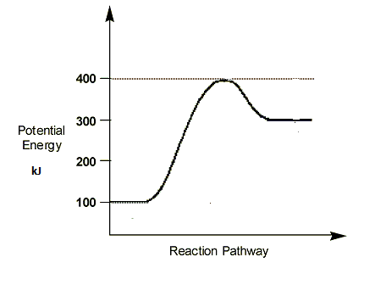
a. Enthalpy of the reactants_____100kJ __________
b. Enthalpy of the products_____300kJ __________
c. Heat of the reaction, ΔH. ____300-100 = +200kJ ____________
- Activation energy of the reaction. ___400- 100= 300kJ __________
Exothermic or Endothermic? . ___ Endothermic (energy of product higher than energy of reactant)_______________
35. Exothermic reactions release (absorb/ release) heat; endothermic reactions absorb (absorb/ release) heat.

Chapter 17 Themochemistry

36. Equal mass of each substance below absorbs 1000J of heat, which would become the hottest? Why?
Substance | Specific Heat Capacity
aluminum | 0.897 J/g°C
iron | 0.454 J/g°C
lead | 0.130 J/g°C
Lowest specific heat capacities heat up fastest

37. What is the difference (in terms of energy) between water at 100°C and steam at 100°C?

Steam at 100°C and water at 100°C have the same average kinetic energy (they are at the same temperature), but steam has much more potential energy than water at the same temperature.

38. The specific heat of aluminum is 0.910J/gºC. A student heats a sample of aluminum to 123°C and places it in a calorimeter containing 150. g of water at 23.0ºC. The final temperature of the system is 43.0ºC. What was the mass of the aluminum sample? (ans: 172g)
 | METAL | WATER
Mass | X | 150 g
specific heat | 0.91 J/g°C | 4.18 J/g°C
T_{i} | 123 °C | 23 °C
T_{f} | 43 °C | 43 °C
∆T | -80 °C | 20 °C

m(sh)(ΔT) = m(sh)(ΔT)
(X)(0.91 J/g°C)(80 °C) = (150g)(4.18 J/g°C)(20°C)
X = 172g

39. The data below refers to substance X.
Melting point | Boiling Point | Heat of Fusion | Heat of Vaporization | Specific Heat Capacity (solid) | Specific Heat Capacity (liquid) | Specific Heat Capacity (vapor)
2.0°C | 52.5°C | 275 J/g | 1240 J/g | 0.90 J/gºC | 1.6 J/gºC | 0.55 J/gºC

- Draw a heating curve for substance X, going from -10ºC to 70ºC on the axis below. Write in all formulas used to calculate heat. Label the phase present at each stage of your graph. Also label changes in potential and kinetic energy.
70°C
Δ K. E.
Δ P. E.

G
H= m Sh ▲T
H= m H_{v}
Δ P. E.

52.5°C
H= m H_{f}
Δ K. E.

L
H= m Sh ▲T
S
Δ K. E.
2°C
H= m Sh ▲T

-10°C

a.. Calculate the amount of heat needed to raise the temperature of 15g of this substance from 54.0°C to 67.3°C.
(ans: 109.7J)
H =m(sh)(ΔT)
H= ( 15g ) (0.55 J/gºC) (13.3°C) = 109.7 J

b. What mass of X can be heated from 20.0°C to 35.0°C using 4000J of heat.
(ans: 166.7g X)
H =m(sh)(ΔT)
4000J = m (1.6 J/gºC) (15°C)
m = 166.7 g

Review: Lab Equipment

40. Identify and give the use for each piece of lab equipment below:
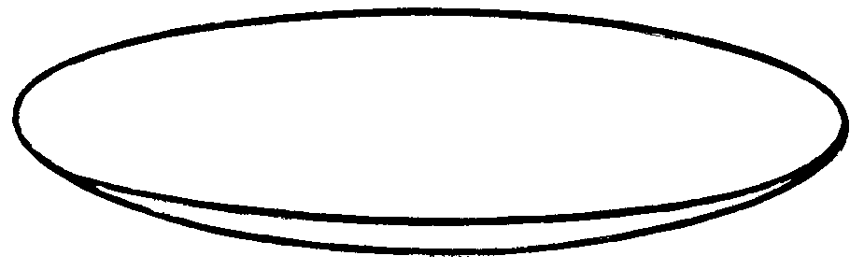 watch glass- to hold solids while being weighed, or as a cover for a beaker or evaporating dish | 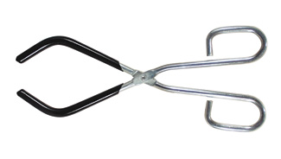beaker tongs – used to transport a hot beaker
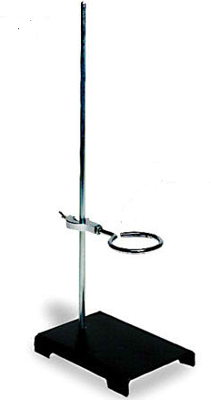 iron ring and a ring stand - to support the laboratory apparatus (ex: while heating solvent) | 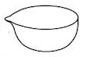  evaporating dish – used to evaporate liquids
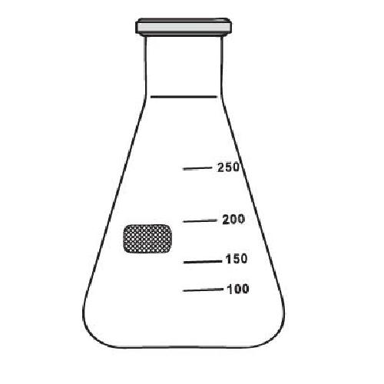 Erlenmeyer flask- are used in chemistry labs for titration ; they are useful in the lab setting for stirring the contents by hand by swirling the flask, as the tapered neck prevents spillage of the contents. | 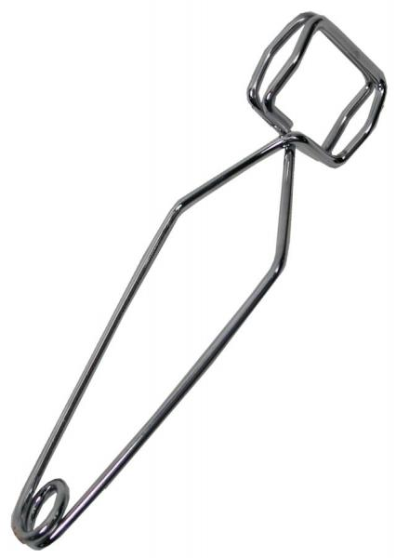Test tube holders – holds test tubes when heating
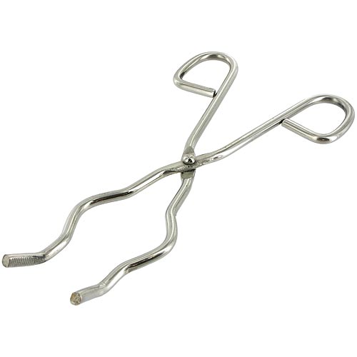 Crucible tongs -used to grasp and take a hot crucible out of a fire or to move a crucible from one location to another. | 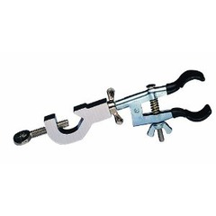Test tube clamp – used to clamp equipment to a ring stand

